Broadway Cabaret
Recital 2023

Class | Teacher | Song | Costume | Tights | Shoes | Hair | Accessories
Sparklers |  | Hopelessly Devoted | Comp Costume | Classic Pink | none | ½ up-½ down | None- no earrings
Shimmers |  | Friend | Comp Costume | Classic Pink | None | High Bun | Crown- No earrings
Creative Movement | Robin | You're Never Fully Dressed Without A Smile  (Annie) | 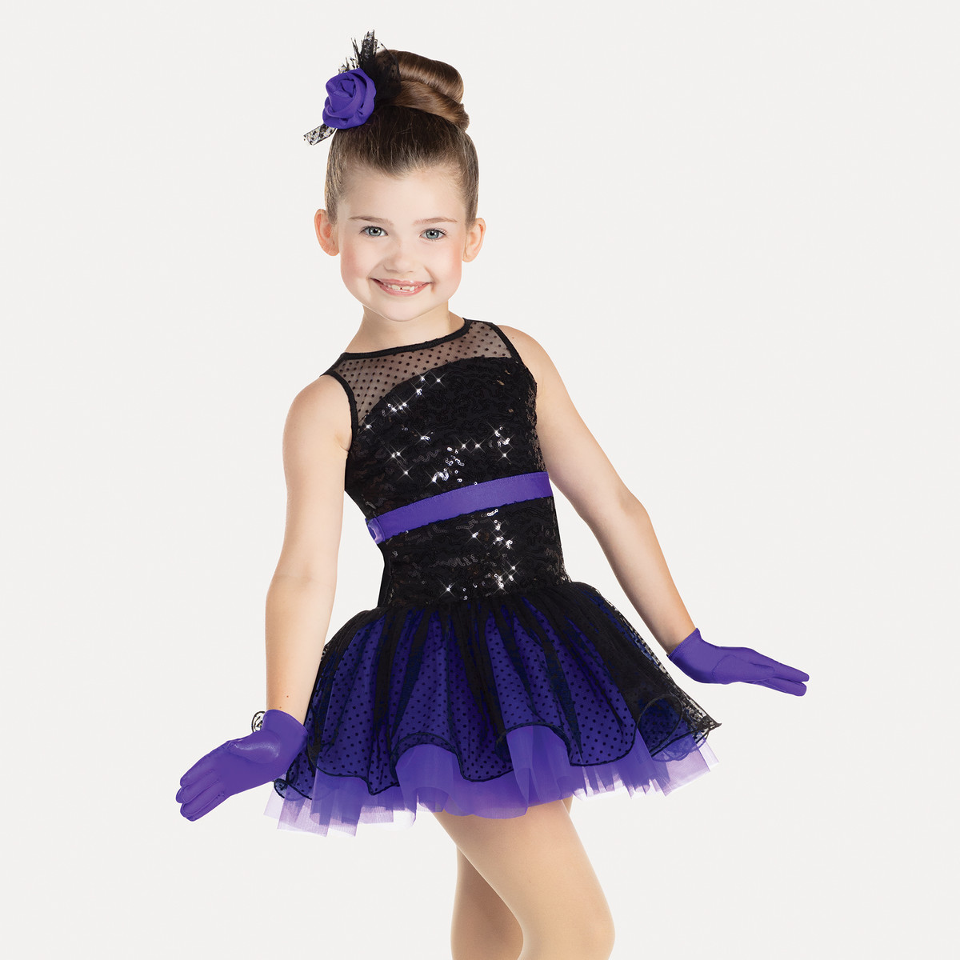 | Classic Pink | Pink Ballet Shoes | Mid Bun | Gloves  Hair Piece on the right Side of Bun
Inter/Adv  Combo | Robin | Ballet-I feel Pretty (West Side Story)  Tap- Putin on the Ritz (Puttin on the Ritz)  Jazz- Top Secret Personal Beeswax (Junie B. Jones- The Musical) | 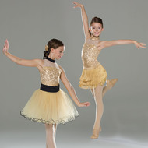 | Classic Pink | Pink Ballet  Black Tap  Black Jazz | High Bun | Ballet- Waist sash, Tutu  Gold Choker- Gold Bow hair piece  Tap- Fringe Skirt, Black/Gold Choker, black hair piece  Jazz- Black Leggings (purchase own) Black/Gold Choker-Gold Bow Hair piece  For All Hair piece on the right side of Bun
Beg/Int Combo | Robin | Ballet- If the World Turned Upside Down (Finding Neverland)  Tap- Fabulous Feet (The Tap Dance Kid) | 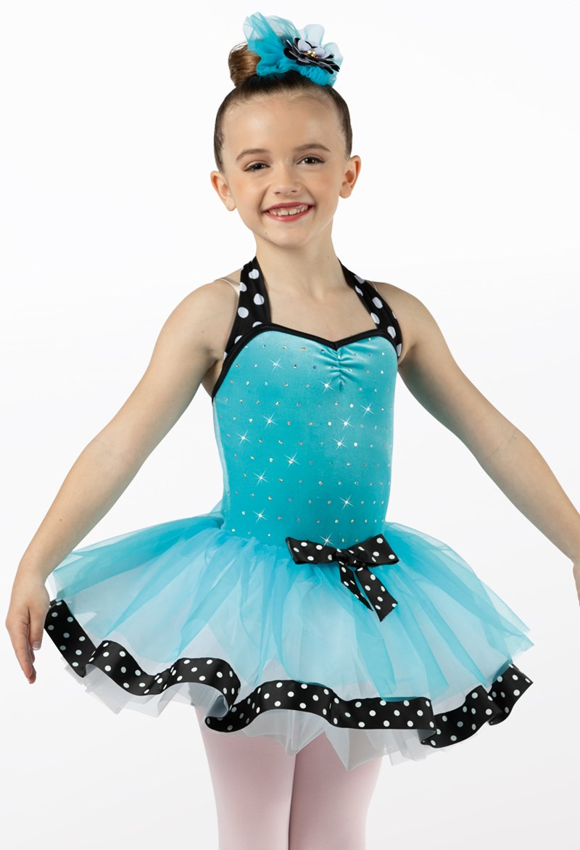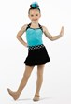 | Classic Pink | Pink Ballet  Black Tap | High Bun | Ballet- Tutu, Center Bow Hair Piece on right side of bun  Tap- Polkadot bows on straps, fringe skirt, gloves, Polkadot Bow- Top of Bun
Lyrical | Mya | I Dreamed A Dream (Les Miserables) |  | Classic Pink | No shoes | ½ up ½ down | No accessories
Hip Hop | Mya | Hard Knock life (Annie)  Black, Red, White, Light Blue Color Scheme | Make your own  Denim Shorts with pockets (appropriate length- No butt cheeks hanging out)  Torn shirts  Bandanas | Classic Pink | Tennis Shoes | Mid Pony to high pony | Bandana- Red  No crop tops  No midriff  Hair piece- your choice of bandana or no–no hats
Modern | Mya | Be Prepared (The Lion King) | 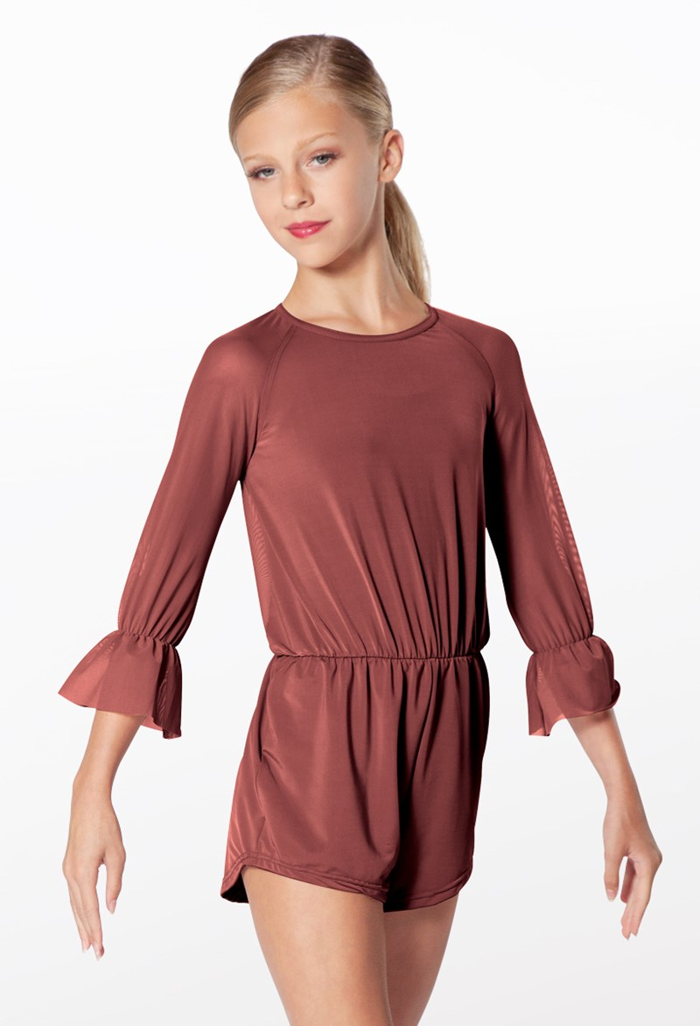 | Classic Pink | None | Low Pony  Mid part | None
Musical Theatre | Mya | You Can’t Stop The Beat (Hairspray) | 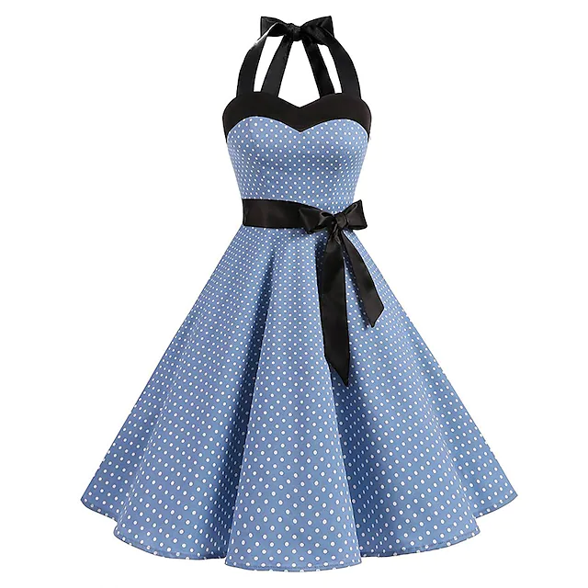 | Classic Pink | Black Heels | High Pony  No part | Black booty shorts underneath- strapless bra
Tumbling | Mya | We Go Together (Grease) |  | None | None | Low Pony  Mid part | Colorful Scarf around the neck
Pointe 2 | Mya | My Favorite Things (Sound of Music) | 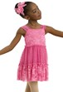 | Classic Pink | Pointe/  Ballet Shoes | Low Bun Middle Part | Hair Piece on the right side of head
Ballet B/C | Mya | Dites-MOI (South Pacific) | 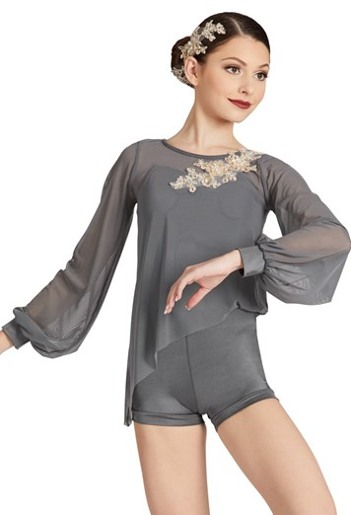 | Classic pink | Pink Ballet Shoes | Low Bun Middle Part | Hair Piece on the Right side of head
Jazz C/D | Melanie | My Boyfriend’s Back (Jersey Boys) | 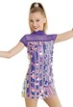 | Classic pink | Tan Jazz | High Pony  No part
Tap C/D | Kate | Popular (Wicked) |  | Classic Pink | Black Taps | High Pony  No part | None
Ballet A | Casey | Dancing Queen (Mama Mia) | 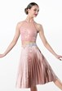 | Classic Pink | Pink Ballet Shoes | Low pony mid part | Clips crisscrossed to make an X on the Right Side
Pointe 1 | Casey | Big Spender (Sweet Charity) |  | Classic Pink | Pointe Shoes | Mid pony  Mid part | Pony Holder
A/B Tap | Casey | Boogie Shoes (Saturday Night Fever) | 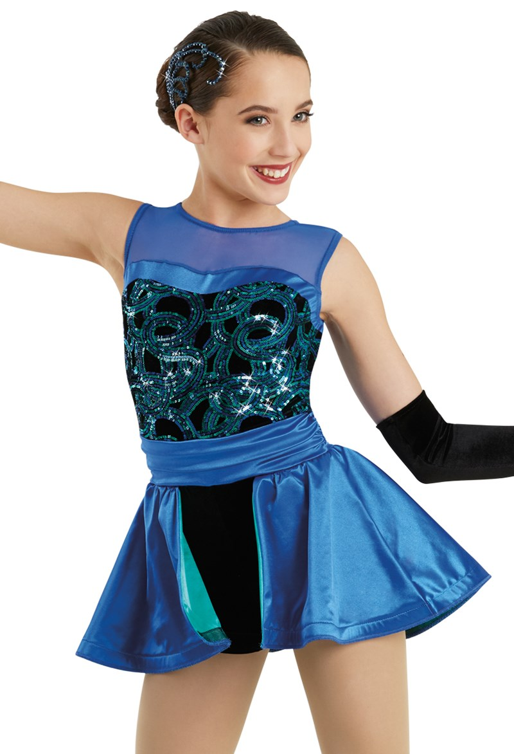 | Classic Pink | Black Taps | Low pony mid part | Hair Piece on the right side of head  gloves
A/B Jazz | Casey | Maniac (Flashdance) | 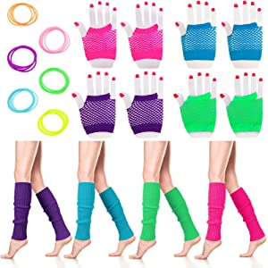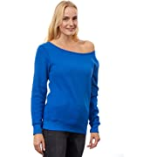 | Classic Pink | Black Jazz | Mid pony mid part | Need black leo under costume

